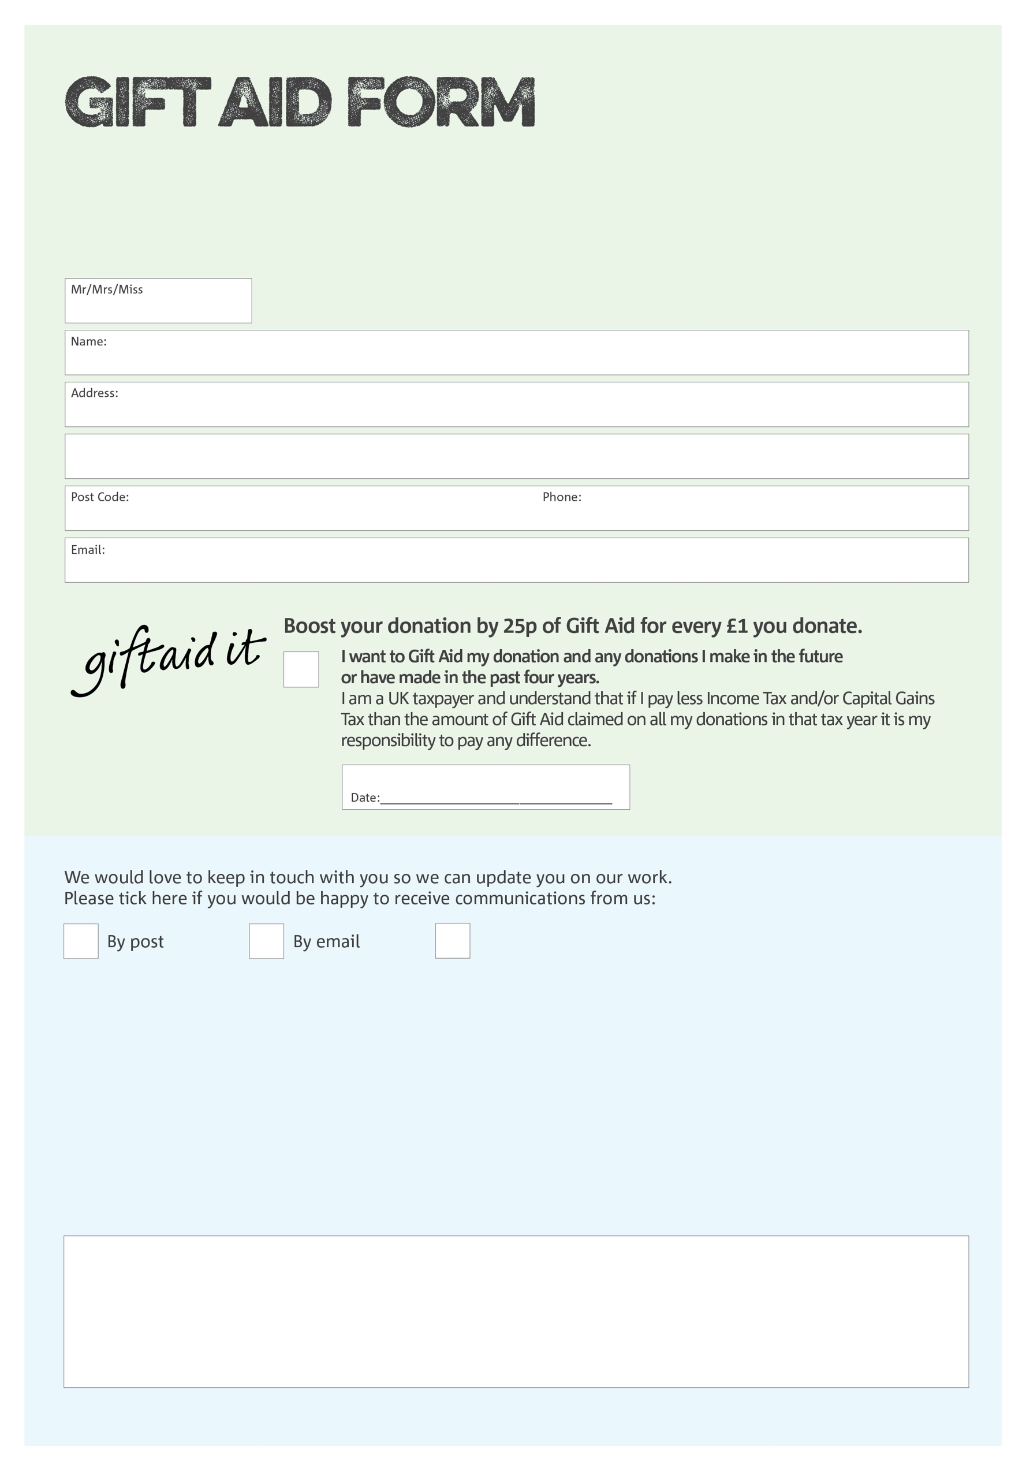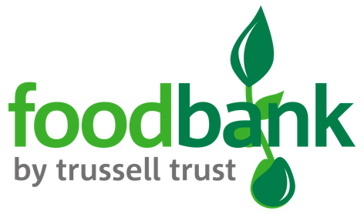

By filling in this form Stretford Foodbank will receive an extra 25p for every £1 you give at no extra cost to you. Thank you!

We would love to know why you have chosen to donate to Stretford Foodbank. If you would like to share your motivation let us know below:

You can change your preferences any time by contacting us on 07564 387 209 or emailing us at

info@stretford.foodbank.org.uk

I do not wish to receive future communications from

Stretford Foodbank

**Data protection**

Stretford Foodbank is committed to protecting your privacy and will process your personal data in accordance with the Data Protection Act 1998. Stretford Foodbank collects information to keep in touch with you and supply you with information relating to our work. Stretford Foodbank will never sell or pass your details to anyone who isn’t directly working on our behalf.

Charity Number 1167416. Registered in England & Wales